Task 1 Input – process - output
Complete the diagrams below outlining the basic operations of various computer systems

- Writing a story using a word processing package
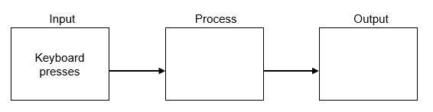
- Showing the position of a car on a Sat Nav
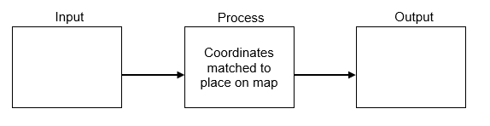
- Taking a photo on a Smartphone
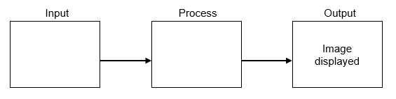
- Paying for a car park ticket in an automated machine
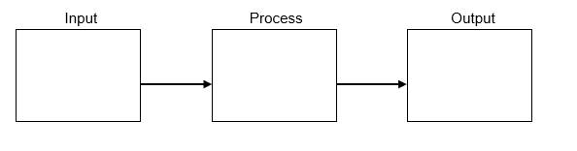

Task 2 System buses
Data within a computer is moved around its various components using a series of interconnections known as system buses.
Complete the diagram below to label the following parts showing the direction in which addresses travel:
Processor, Data bus, Address bus, Main memory, I/O controller
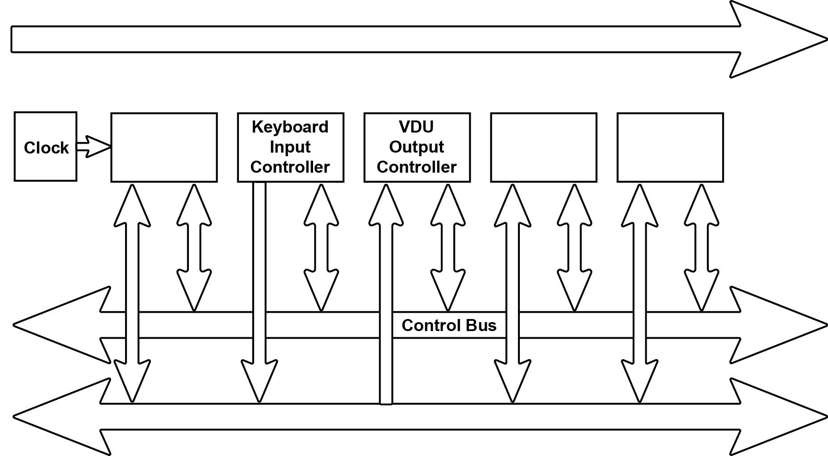

Task 3 Word length
Memory is divided into equal units called words. Each word has a separate memory address.
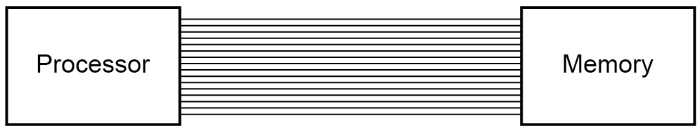
A processor uses a word length of 16 bits and has an address bus of 16 lines.
a) What is the maximum number of addressable words in memory?
b) What is the overall memory capacity KiB?
c) How does the width of the address bus affect system performance?
d) How does the width of the data bus affect system performance?
Task 4 Memory and the stored program concept
Using standard von Neumann architecture, instructions and data both share the same memory space.
Memory
Address | Instruction / Data
0 | 10010111 00101111
1
2 | 00000000 11010100
… | …
255 | 00000000 01001010
One problem with this model is that the CPU can either be reading an instruction or reading/writing data to or from memory, but not both at the same time since instructions and data use the same bus system, which is a performance limitation.
- Name another architecture that resolves this issue. How does it differ from von Neumann architecture?

- What other advantages are there of using this architecture?

